20CYS312 - Principles of Programming Languages
Lab 6
A Arjun
CH.EN.U4CYS22006
GitHub : https://github.com/12005/Haskell-Lab
Objective
These lab questions aim to strengthen your understanding of Haskell by focusing on key concepts like higher-order functions, currying, and lambda expressions. You'll practice using map, filter, and fold for data manipulation and learn to handle input/output operations, including file handling. Overall, the exercises enhance your skills in functional programming and efficient Haskell coding.
Higher Order Functions
1. Currying, Map, and Fold:
CODE
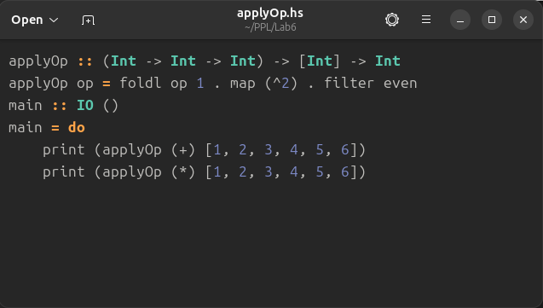
EXPLAINATION
Computes the sum of squares of even numbers from a list.
OUTPUT
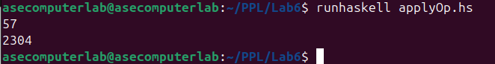

2. Map, Filter, and Lambda.
CODE
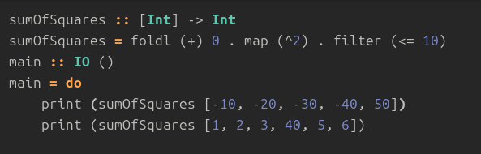
EXPLAINATION
Filters numbers greater than 10, squares the remaining, and sums them.
OUTPUT
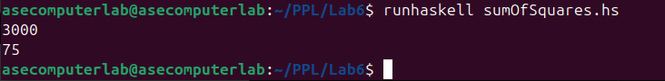
3. Currying, Function Composition, and Map
CODE
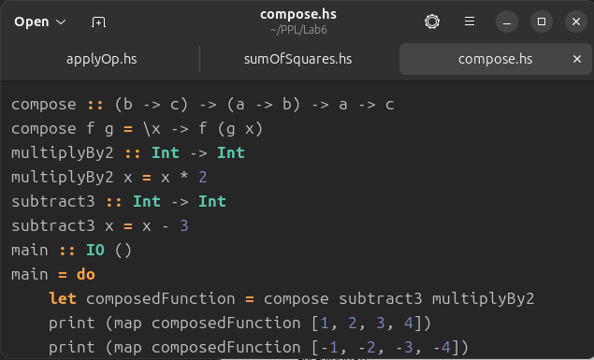

EXPLAINATION
Compose the functions: multiply by 2, then subtract 3. Apply the composed function to each element in the list [1, 2, 3, 4]
OUTPUT
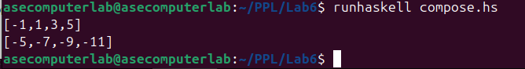

4. Currying, Filter, and Fold
CODE
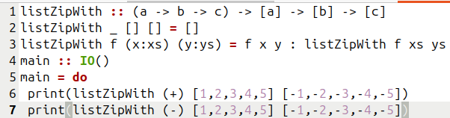
EXPLAINATION
This function behaves like zipWith. It takes a function and two lists, applying the function to corresponding elements of both lists.
OUTPUT

5.Write a recursive function reverseList that takes a list of elements and returns the list in reverse order. For example, given [1, 2, 3], the output should be [3, 2, 1].
CODE
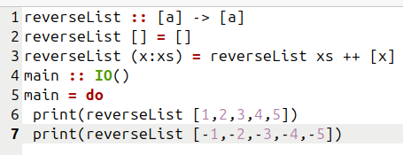
EXPLAINATION
This function takes a list and reverses it recursively.
OUTPUT

6. You are tasked with developing a program to manage and analyze student records. Each student is represented as a tuple (String, Int, [Int]), where the first element is the student’s name (a string), the second is their roll number (an integer), and the third is a list of integers representing their marks in various subjects. Write a recursive function averageMarks to calculate the average of a student's marks. Display all student names and their average marks.
CODE
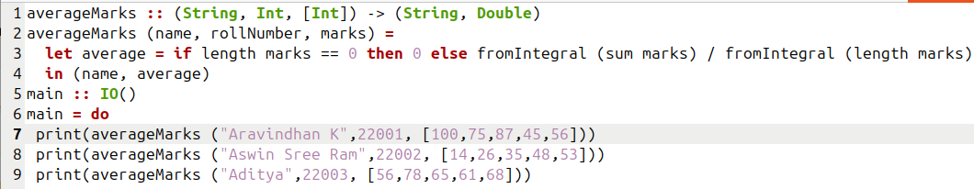
EXPLAINATION
This function calculates the average of a student's marks. It takes a tuple (String, Int, [Int]), representing the student's name, roll number, and list of marks. The function calculates the average of the marks and returns it.
OUTPUT
CONCLUSION
In this exercise, we focused on implementing basic recursive functions and list manipulation in Haskell. Tasks such as swapping tuple elements, using list comprehensions, filtering even numbers, reversing a list, and calculating student averages helped reinforce our understanding of functional programming techniques and working with lists and tuples.

